Here’s a concise but comprehensive list of common network ports and their typical protocols/uses — great for teaching, troubleshooting, or general networking reference.

🔹 Well-Known Ports (0–1023)
Port | Protocol | Common Use
20 | TCP | FTP – Data transfer
21 | TCP | FTP – Command/control
22 | TCP | SSH – Secure Shell, SFTP, SCP
23 | TCP | Telnet – Remote login (insecure)
25 | TCP | SMTP – Mail transfer
53 | TCP/UDP | DNS – Domain name resolution
67 | UDP | DHCP – Server (assign IP addresses)
68 | UDP | DHCP – Client
69 | UDP | TFTP – Trivial File Transfer
80 | TCP | HTTP – Web traffic
110 | TCP | POP3 – Incoming mail (old)
119 | TCP | NNTP – Network News
123 | UDP | NTP – Network Time Protocol
135 | TCP | Microsoft RPC (DCOM)
137–139 | TCP/UDP | NetBIOS – Windows file/printer sharing
143 | TCP | IMAP – Incoming mail
161/162 | UDP | SNMP – Network management (agent/trap)
179 | TCP | BGP – Border Gateway Protocol
389 | TCP/UDP | LDAP – Directory services
443 | TCP | HTTPS – Secure web traffic
445 | TCP | SMB – Windows file sharing over TCP
465 | TCP | SMTPS – Secure mail submission
514 | UDP | Syslog – System logging
515 | TCP | LPD – Printer service
587 | TCP | SMTP (submission)
631 | TCP/UDP | IPP – Internet Printing Protocol
636 | TCP | LDAPS – Secure LDAP
993 | TCP | IMAPS – Secure IMAP
995 | TCP | POP3S – Secure POP3

🔹 Registered Ports (1024–49151)
Port | Protocol | Common Use
1433 | TCP | Microsoft SQL Server
1434 | UDP | SQL Server Browser Service
1521 | TCP | Oracle Database
2049 | TCP/UDP | NFS – Network File System
2181 | TCP | Apache ZooKeeper
2375 | TCP | Docker (non-TLS)
2376 | TCP | Docker (TLS secured)
2483/2484 | TCP | Oracle DB listener (plain/SSL)
3268 | TCP | Global Catalog (Active Directory)
3306 | TCP | MySQL / MariaDB
3389 | TCP | RDP – Remote Desktop Protocol
5432 | TCP | PostgreSQL
5672 | TCP | RabbitMQ (AMQP)
5900 | TCP | VNC – Remote desktop
5985 | TCP | WinRM (HTTP)
5986 | TCP | WinRM (HTTPS)
6379 | TCP | Redis
6443 | TCP | Kubernetes API Server
6667 | TCP | IRC – Internet Relay Chat
8000 | TCP | Common for dev/test web servers
8080 | TCP | HTTP alternative / proxy
8443 | TCP | HTTPS alternative / admin consoles
9000 | TCP | SonarQube / dev tools / custom apps
9092 | TCP | Apache Kafka
9200 | TCP | Elasticsearch
9418 | TCP | Git (native protocol)
9999 | TCP | Misc admin ports (custom apps)

🔹 Dynamic / Private Ports (49152–65535)
Used for ephemeral (temporary) connections — typically client-side ports chosen dynamically by the OS for outgoing connections.

Would you like me to include a diagram or visual grouping (e.g., “Web”, “Mail”, “Database”, “Remote Access”, “Infrastructure”) to help students memorise them logically?

netstat -an will tell you what ports are open for connection

mime – multipurpose internet mail exchange – authoritative version of a file extension.

Localhost is an alias for yourself
So is any IP address that starts 127.x.y.z e.g. 127.0.0.1
Absolutely — here’s a clear, categorized list of common MIME (Multipurpose Internet Mail Extensions) types, often used in web development, APIs, and file transfers.

🔹 Text Formats
File Type | MIME Type | Notes
Plain text | text/plain | Default for .txt files
HTML | text/html | Standard web pages
CSS | text/css | Stylesheets
CSV | text/csv | Comma-separated values
JavaScript | text/javascript or application/javascript | Modern standard is application/javascript
Markdown | text/markdown | For .md files
XML | application/xml or text/xml | Both seen; application/xml preferred

🔹 Images
File Type | MIME Type | Notes
JPEG | image/jpeg | .jpg, .jpeg
PNG | image/png | .png
GIF | image/gif | .gif
BMP | image/bmp | .bmp
WebP | image/webp | Modern web image format
SVG | image/svg+xml | Scalable vector graphics
ICO | image/x-icon | Website favicons

🔹 Audio
File Type | MIME Type | Notes
MP3 | audio/mpeg | Most common audio type
WAV | audio/wav | Uncompressed
OGG | audio/ogg | Open format
AAC | audio/aac | Used in MP4 containers
MIDI | audio/midi | Instrumental sound data

🔹 Video
File Type | MIME Type | Notes
MP4 | video/mp4 | Most common video format
WebM | video/webm | Open web format
OGG | video/ogg | Alternate open format
AVI | video/x-msvideo | Legacy format
MPEG | video/mpeg | Older standard

🔹 Applications / Binary Files
File Type | MIME Type | Notes
Binary | application/octet-stream | Default for arbitrary binary data
JSON | application/json | Common in APIs
PDF | application/pdf | Portable Document Format
ZIP | application/zip | Compressed archive
GZIP | application/gzip | Gzip-compressed data
TAR | application/x-tar | Unix archive
RAR | application/vnd.rar | RAR archive
Excel (old) | application/vnd.ms-excel | .xls
Excel (new) | application/vnd.openxmlformats-officedocument.spreadsheetml.sheet | .xlsx
Word (old) | application/msword | .doc
Word (new) | application/vnd.openxmlformats-officedocument.wordprocessingml.document | .docx
PowerPoint (old) | application/vnd.ms-powerpoint | .ppt
PowerPoint (new) | application/vnd.openxmlformats-officedocument.presentationml.presentation | .pptx
Java Archive | application/java-archive | .jar
JSON-LD | application/ld+json | Linked Data JSON

🔹 Fonts
File Type | MIME Type | Notes
TTF | font/ttf | TrueType font
OTF | font/otf | OpenType font
WOFF | font/woff | Web Open Font Format
WOFF2 | font/woff2 | Compressed version

🔹 Multipart / Form Data
Type | MIME Type | Notes
Form (URL encoded) | application/x-www-form-urlencoded | Standard HTML form submissions
Form (with files) | multipart/form-data | Used when uploading files
Email mixed parts | multipart/mixed | Attachments, emails, etc.
Email alternative | multipart/alternative | HTML + plain text emails

HTTP Codes:
🔹 1xx — Informational
Code | Meaning | Description
100 | Continue | Server received request headers; client can proceed.
101 | Switching Protocols | Server is changing protocols (e.g. to WebSocket).
102 | Processing | Used in WebDAV; request received but not completed yet.

🔹 2xx — Success
Code | Meaning | Description
200 | OK | Request succeeded; normal success response.
201 | Created | Resource created successfully (e.g., POST).
202 | Accepted | Request accepted but processing is not complete.
204 | No Content | Success but no body returned (e.g., DELETE).
206 | Partial Content | Used for range requests (e.g., video streaming).

🔹 3xx — Redirection
Code | Meaning | Description
301 | Moved Permanently | Resource permanently moved to a new URL.
302 | Found | Temporary redirect (commonly used for “Moved Temporarily”).
303 | See Other | Redirect using GET (after POST).
304 | Not Modified | Cached version still valid; no need to resend.
307 | Temporary Redirect | Like 302 but doesn’t change HTTP method.
308 | Permanent Redirect | Like 301 but keeps the HTTP method.

🔹 4xx — Client Errors
Code | Meaning | Description
400 | Bad Request | Invalid syntax or parameters in request.
401 | Unauthorized | Authentication required or failed.
403 | Forbidden | Authenticated but not allowed to access resource.
404 | Not Found | Resource doesn’t exist at this location.
405 | Method Not Allowed | HTTP method not supported (e.g., POST on a GET-only endpoint).
408 | Request Timeout | Client took too long to send the request.
409 | Conflict | Resource conflict (e.g., duplicate data).
410 | Gone | Resource permanently removed.
413 | Payload Too Large | Request body too big.
415 | Unsupported Media Type | Content-Type not supported.
418 | I’m a teapot 🫖 | April Fools RFC 2324 (fun Easter egg).
429 | Too Many Requests | Rate-limiting — too many requests in a short time.

🔹 5xx — Server Errors
Code | Meaning | Description
500 | Internal Server Error | Generic server error (catch-all).
501 | Not Implemented | Server doesn’t support this feature.
502 | Bad Gateway | Invalid response from an upstream server.
503 | Service Unavailable | Server temporarily overloaded or down for maintenance.
504 | Gateway Timeout | Upstream server didn’t respond in time.
505 | HTTP Version Not Supported | Protocol version not supported.

🔹 Quick Cheat Grouping
Category | Range | Example
Informational | 100–199 | 100 Continue
Success | 200–299 | 200 OK, 201 Created
Redirection | 300–399 | 301 Moved Permanently
Client Error | 400–499 | 404 Not Found
Server Error | 500–599 | 500 Internal Server Error

Special HTML Characters

🔹 Core Characters
Character | Entity Name | Entity Number | Description
& | &amp; | &#38; | Ampersand
< | &lt; | &#60; | Less than
> | &gt; | &#62; | Greater than
" | &quot; | &#34; | Double quote
' | &apos; | &#39; | Apostrophe / single quote
(non-breaking space) | &nbsp; | &#160; | Prevents line breaks

🔹 Punctuation & Symbols
Character | Entity Name | Entity Number | Description
© | &copy; | &#169; | Copyright
® | &reg; | &#174; | Registered trademark
™ | &trade; | &#8482; | Trademark
§ | &sect; | &#167; | Section sign
¶ | &para; | &#182; | Paragraph sign
• | &bull; | &#8226; | Bullet
… | &hellip; | &#8230; | Ellipsis
– | &ndash; | &#8211; | En dash
— | &mdash; | &#8212; | Em dash
“ | &ldquo; | &#8220; | Left double quote
” | &rdquo; | &#8221; | Right double quote
‘ | &lsquo; | &#8216; | Left single quote
’ | &rsquo; | &#8217; | Right single quote
‹ | &lsaquo; | &#8249; | Single left angle quote
› | &rsaquo; | &#8250; | Single right angle quote
« | &laquo; | &#171; | Double left angle quote
» | &raquo; | &#187; | Double right angle quote

🔹 Mathematical Symbols
Character | Entity Name | Entity Number | Description
± | &plusmn; | &#177; | Plus/minus
× | &times; | &#215; | Multiplication
÷ | &divide; | &#247; | Division
≠ | &ne; | &#8800; | Not equal
≤ | &le; | &#8804; | Less than or equal
≥ | &ge; | &#8805; | Greater than or equal
∞ | &infin; | &#8734; | Infinity
√ | &radic; | &#8730; | Square root
≈ | &asymp; | &#8776; | Approximately equal
∑ | &sum; | &#8721; | Summation
∏ | &prod; | &#8719; | Product symbol
∂ | &part; | &#8706; | Partial differential
∫ | &int; | &#8747; | Integral
π | &pi; | &#960; | Pi
µ | &micro; | &#181; | Micro

🔹 Currency Symbols
Character | Entity Name | Entity Number | Description
£ | &pound; | &#163; | British Pound
€ | &euro; | &#8364; | Euro
¥ | &yen; | &#165; | Yen
¢ | &cent; | &#162; | Cent

🔹 Arrows
Character | Entity Name | Entity Number | Description
← | &larr; | &#8592; | Left arrow
↑ | &uarr; | &#8593; | Up arrow
→ | &rarr; | &#8594; | Right arrow
↓ | &darr; | &#8595; | Down arrow
↔ | &harr; | &#8596; | Left-right arrow
⇐ | &lArr; | &#8656; | Double left arrow
⇒ | &rArr; | &#8658; | Double right arrow
⇔ | &hArr; | &#8660; | Double left-right arrow

🔹 Miscellaneous
Character | Entity Name | Entity Number | Description
† | &dagger; | &#8224; | Dagger
‡ | &Dagger; | &#8225; | Double dagger
‰ | &permil; | &#8240; | Per mille
′ | &prime; | &#8242; | Prime (minutes or feet)
″ | &Prime; | &#8243; | Double prime (seconds or inches)
Ø | &Oslash; | &#216; | Capital O slash
ø | &oslash; | &#248; | Small o slash
Æ | &AElig; | &#198; | Capital AE ligature
æ | &aelig; | &#230; | Small ae ligature
ß | &szlig; | &#223; | German sharp s

Creating an Icon for the Browser Tab
🔹 1. Create the Icon
✅ Basic requirements
- Size: at least 32×32 pixels, ideally 512×512 for modern browsers.
- Format:
  - .ico (traditional, most compatible)
  - .png (modern, cleaner, supports transparency)
To use the icon, put this into the head section:
<link rel="icon" type="image/png" href="/favicon.png">
However, if you want to guarantee it works across Apple, Android, tablets, browsers etc use this:
<!-- Apple iOS icon -->
<link rel="apple-touch-icon" sizes="180x180" href="/apple-touch-icon.png">
<!-- Android/Chrome high-res icon -->
<link rel="icon" sizes="192x192" href="/android-chrome-192x192.png">
<link rel="icon" sizes="512x512" href="/android-chrome-512x512.png">
Comparison of .gif, .jpeg, .png and .webp files:
🖼️ Web Image Format Comparison
Feature | GIF | JPEG / JPG | PNG | WebP
Full name | Graphics Interchange Format | Joint Photographic Experts Group | Portable Network Graphics | Web Picture format
Year introduced | 1987 | 1992 | 1996 | 2010 (by Google)
Compression type | Lossless (LZW) | Lossy (DCT-based) | Lossless (DEFLATE) | Both lossy & lossless
Color depth | 8-bit (256 colors) | 24-bit (16.7M colors) | 24-bit color + 8-bit alpha (32-bit total) | Up to 24-bit color + 8-bit alpha
Transparency support | 1-bit (on/off) | ❌ None | ✅ Full alpha transparency | ✅ Full alpha transparency
Animation support | ✅ Yes | ❌ No | ❌ (standard PNG) / ✅ APNG variant | ✅ Yes (animated WebP)
Typical use | Simple graphics, icons, memes | Photographs, gradients | Logos, UI graphics, screenshots | Modern replacement for JPEG/PNG/GIF
Compression efficiency | Medium | Excellent for photos | Excellent for flat colors | Superior (smaller files, same quality)
File size (typical) | Small for simple art | Small for photos | Larger for photos | 25–35% smaller than JPEG/PNG
Transparency quality | Jagged edges | None | Smooth alpha | Smooth alpha
Browser support | ✅ Universal | ✅ Universal | ✅ Universal | ✅ Modern browsers (Chrome, Edge, Firefox, Safari 14+)
Best for | Basic animation, limited color art | Photos and complex images | Crisp graphics needing transparency | Everything — modern general-purpose format
Open / patented? | Formerly patented | Open | Open | Open (Google-developed)

🧠 Summary
🟢 Use JPEG → for photos (small, efficient, doesn’t need transparency).
🟣 Use PNG → for logos, icons, screenshots, or anything needing crisp edges or transparency.
🟠 Use GIF → only for simple animations (memes, loading icons).
🔵 Use WebP → for modern web images — smaller files, supports both transparency and animation.

URL Encoding
Textbox 1 Name=fn
Textbox 2 Name=ln
Name assigns names to the “variables”/parmeters.
If you use ID as an attribute, not name, the machine will assume to make the name and id the same.
Fn=Mike&ln=Howell&ud=mhowell&pw=banana

GET: (does what it always does, requests a page)
Click submit.
Destinationpage.html?fn=Mike&ln=Howell&ud=mhowell&pw=banana
The browser URL shows the data you are transmitting.
Plus you are limited about 4kb of “data”.

POST: Official way to transmit data (HTTPS)
The browser create a new web page body containing the URL encoded data, and then “uploads” it to the server.

CSS
The evolution of World Wide Web Consortium (W3C)’s CSS spec is indeed modular and each module is handled somewhat independently (though still coordinated). I’ll walk you through how this works and then show a list of key modules + their current levels.

✅ How CSS development is structured
Here are the main points:
- One main group: the CSS Working Group (CSSWG) is responsible for the overall CSS language. (W3C)
- But rather than one monolithic “CSS4/5” document, CSS is broken into modules (e.g., Selectors, Color, Grid, Flexbox, Cascade & Inheritance). (drafts.csswg.org)
- Each module has its “level” (Level 1, Level 2, Level 3, Level 4, …) depending on how mature it is. And modules progress at their own pace. (drafts.csswg.org)
- Modules also go through W3C’s standardization process: Working Draft → Candidate Recommendation → Recommendation. The CSSWG describes this in their “CSS Snapshot” doc. (drafts.csswg.org)
- Because modules progress separately, you might see “Selectors Level 4” while “Grid Layout Module Level 3” is still being refined. That’s entirely normal. (W3C)
So yes — different parts of CSS (selectors, layout, color, UI, etc) are developed, reviewed and advanced somewhat independently, but under the governance of the same overall working group (CSSWG). There aren’t totally separate unrelated committees for each module (they report to W3C / CSSWG), but the modules give more manageable “chunks” for development.

📝 Key CSS Modules & Their Levels (useful for teaching)
Here’s a selection of modules, their “level” status as of now, and a quick note you can share with your students (especially helpful given your teaching background in JS, React, etc). Note: “Level” here is per-module, not a whole-language version.
Module | Current Level | What it covers / why it matters | Teaching tip (T-SQL comparison style)
Selectors (e.g. pseudo-classes, combinators) | Level 3 → Level 4 working | Enables more powerful ways of selecting elements (e.g., :has(), complex combinators) (drafts.csswg.org) | Like adding new advanced JOIN types or window-functions in T-SQL — selectors let you “query” your DOM elements more precisely.
Grid Layout Module | Level 1 & Level 2 done, Level 3 in draft | 2D layout system for web UI: rows + columns, subgrid, masonry ideas (W3C) | Comparable to upgrading from basic table joins to full OLAP cubes – more dimensional control.
Cascade & Inheritance Module | Level 4/5 | Defines how CSS rules override each other, inheritance, specificity, layers (drafts.csswg.org) | Similar to how you manage hierarchical permissions or schema inheritance in a database.
Color Module | Level 4/5 (ongoing) | Defines color spaces, functions (e.g., lab(), lch()), mixed mode colors (drafts.csswg.org) | Think of it as adding new data types (e.g., geography types in SQL Server) that expand what you can express.
Flexbox Layout Module | Level 1 (stable) | A simpler one-dimensional layout model (rows or columns) widely supported | Just like basic CRUD operations in SQL: foundational and stable.

If you like, I can generate a fuller list (say 15-20 modules) with their current levels + browser support status + “what changed since previous level” — tailored for adult students of JS/React so they can see what features are safe to teach/use and what are still experimental. Would you like me to pull that together?

SASS and LESS
Add on tools are available that allow you to parametrize CSS and implement devices such as inheritance from root element. Have a look at tools such as SASS, LESS.
They are both CSS preprocessors.
Meaning: you write code in a richer “CSS-like” language → it compiles down to plain CSS that the browser understands.
✅ What Sass & Less have in common
Feature | Sass | Less
Variables | ✅ | ✅
Nesting | ✅ | ✅
Mixins (reusable blocks) | ✅ | ✅
Functions & math | ✅ | ✅
Imports / modular CSS | ✅ | ✅
Both aim to:
- Make CSS more maintainable for larger projects
- Add logic to styling (like you’re used to in real programming languages)
- Reduce repetition
Less is falling by the wayside and so avoid using it in newer projects.

Units of CSS Measurement

Type | Unit | Meaning | Example Usage | Notes
Absolute | px | Pixels | font-size: 14px | Fixed — doesn’t scale with zoom or text settings as nicely
 | in | Inches | width: 1in | 1in = 96px (CSS reference)
 | cm | Centimeters | width: 10cm | 1cm ≈ 37.8px
 | mm | Millimeters | width: 5mm | Rarely used
 | pt | Points | font-size: 12pt | 1pt = 1/72in
 | pc | Picas | font-size: 1pc | 1pc = 12pt
Relative to Font | em | Relative to parent font-size | margin: 2em | Stacks — can compound unexpectedly
 | rem | Relative to root font-size | font-size: 1.5rem | Most stable choice for scalable typography
Relative to Viewport | vw | 1% of viewport width | width: 50vw | Great for responsive layouts
 | vh | 1% of viewport height | height: 100vh | Beware of mobile browser URL bar behavior
 | vmin | Smaller of vw or vh | font-size: 2vmin | Keeps proportions in any orientation
 | vmax | Larger of vw or vh | Useful for full-screen elements
Relative to Element Size | % | Percentage of parent | width: 80% | Depends heavily on container
 | ex | x-height (height of “x”) | Typography fine-tuning
 | ch | Width of “0” | Aligning monospaced content
Newer / Advanced | fr | CSS Grid fractional unit | grid-template-columns: 1fr 2fr | Uses leftover space
 | lh | Line height of element | margin-top: 2lh | Helpful for rhythm in text layout
 | rlh | Line height of root | Consistent typography
Others | angle units | deg, rad, turn | rotate(45deg) | For transforms, gradients
 | time units | s, ms | transition: 300ms | Animation and transitions
 | resolution units | dpi, dpcm | Mostly media queries

🔥 Practical Guidance
- ✅ Prefer rem for scalable & accessible text
- ✅ Use vw/vh for fluid, screen-size-driven layouts
- ✅ Use % for layout components inside containers
- ✅ Use fr in CSS Grid for easiest flexible spacing
- ⚠️ Avoid absolute units for screen UI except icons or borders

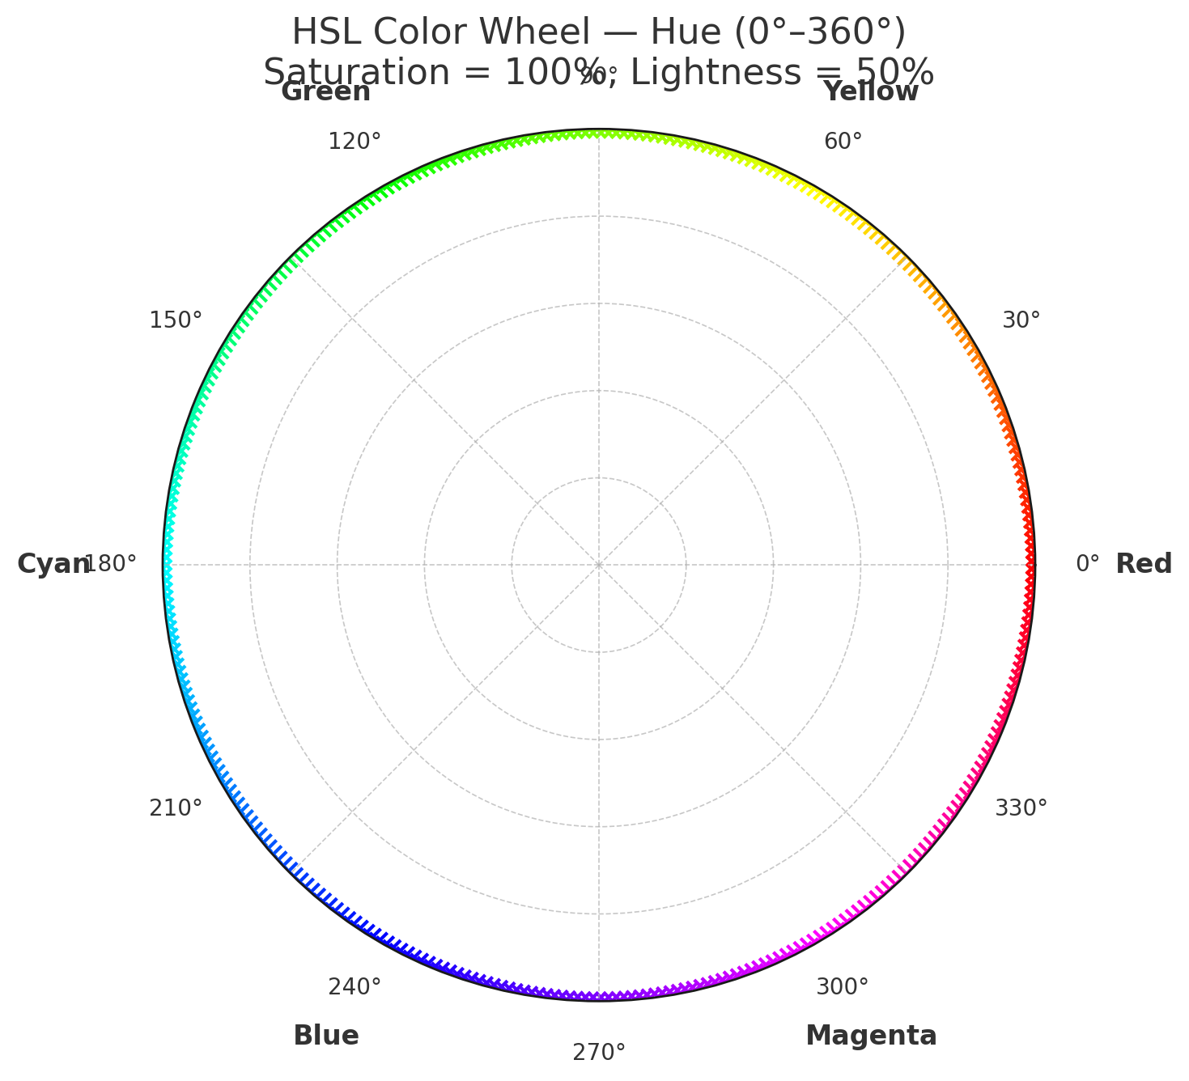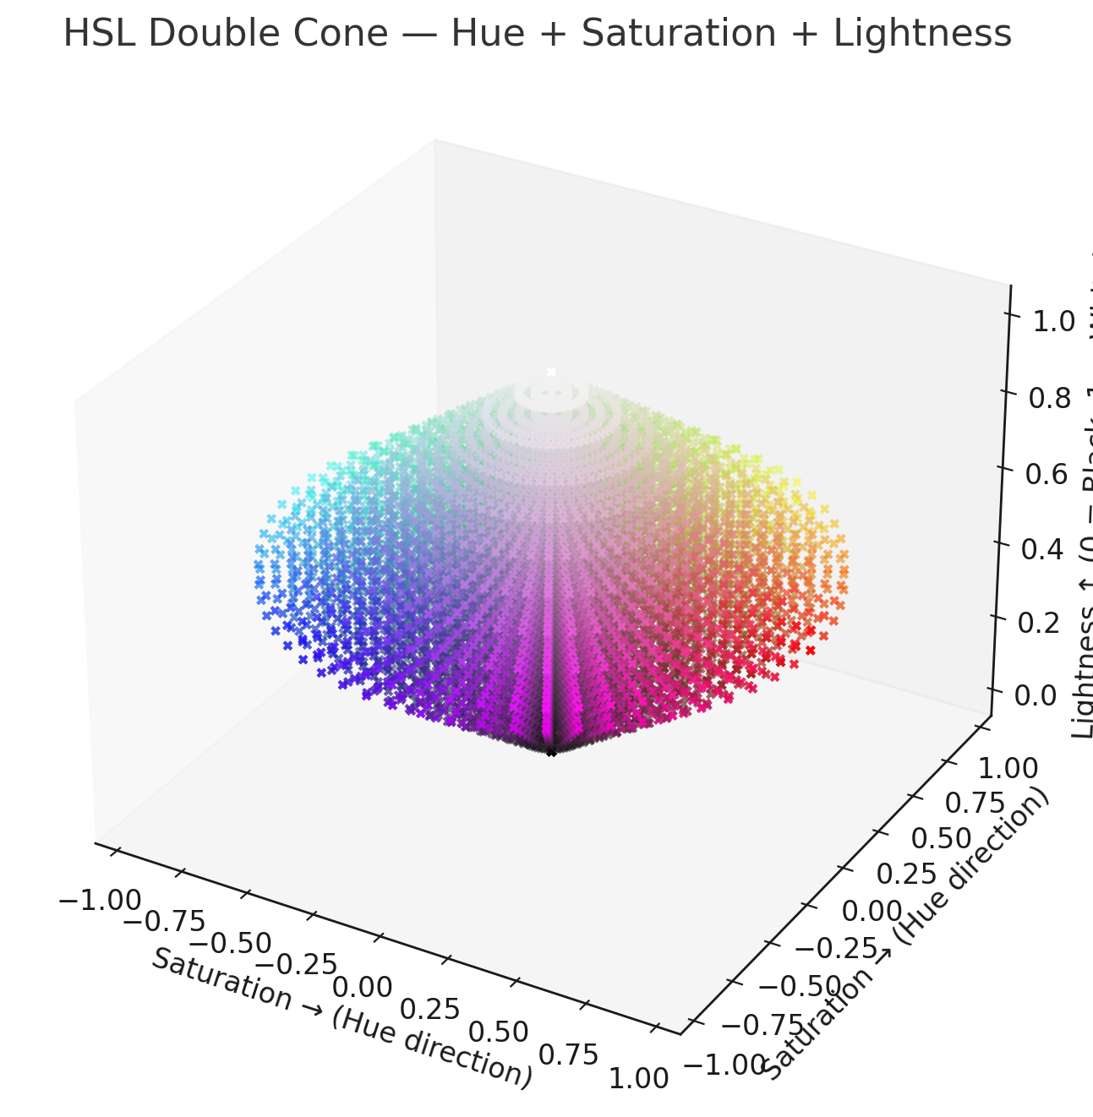

Symbol | Name | Meaning
(space) | Descendant combinator | Selects elements inside another element (any level deep).
> | Child combinator | Selects direct children only.
+ | Adjacent sibling combinator | Selects the next sibling immediately following another.
~ | General sibling combinator | Selects all siblings that follow another (not just the first).
` | Examples: | `
/* Descendant */
div p { ... } /* Any <p> inside a <div> */

/* Child */
div > p { ... } /* <p> is a direct child of a <div> */

/* Adjacent sibling */
h1 + p { ... } /* First <p> right after an <h1> */

/* General sibling */
h1 ~ p { ... } /* All <p> after an <h1> in the same parent */

/* Column (rare) */
colgroup || td { ... }

Symbol | Meaning | Example
= | Exact match | a[target="_blank"]
!= (rare, deprecated in CSS spec drafts) | Not equal (not widely supported)
^= | Starts with | a[href^="https"]
$= | Ends with | img[src$=".png"]
*= | Contains | div[class*="error"]
` | =` | Equal or prefix before -
~= | Contains a space-separated word | class~="active"
Symbol | Example | Meaning
: | :hover, :active | Pseudo-classes (state-based)
:: | ::before, ::after | Pseudo-elements (generated elements)

Viewport
The viewport <meta> element is used (mainly on mobile) to control how the browser sizes, scales, and renders the page. It accepts several well-defined properties, though only a few are commonly used today.
Here is the complete and accurate list of options supported by modern browsers:

✅ Most Important / Commonly Used Viewport Properties
1. width
Controls the CSS pixel width of the layout viewport.
Values:
- device-width → match the screen’s width
- specific value → e.g., width=1024
2. initial-scale
Initial zoom level when the page loads.
Example:
- initial-scale=1.0 (no zoom)
3. maximum-scale
How far the user is allowed to zoom in.
Example:
- maximum-scale=3
4. minimum-scale
How far the user can zoom out.
Example:
- minimum-scale=1
5. user-scalable
Whether the user is allowed to zoom at all.
Values:
- yes (default)
- no (disables pinch-to-zoom — normally discouraged for accessibility)

📦 Less common or legacy properties
6. height
Rarely used; browsers generally ignore it.
- height=device-height
7. target-densitydpi (deprecated)
Older Android browsers only. Now obsolete.

🎯 The most common, recommended viewport line
This is what you will see in nearly every modern HTML document:
<meta name="viewport" content="width=device-width, initial-scale=1">
That’s all you generally need.

🧩 Examples Showing the Options
Allow zooming up to 5×:
<meta name="viewport" content="width=device-width, initial-scale=1, maximum-scale=5">
Disable zoom (not recommended for accessibility):
<meta name="viewport" content="width=device-width, initial-scale=1, user-scalable=no">
Lock zoom and stop resizing:
<meta name="viewport" content="width=device-width, initial-scale=1, minimum-scale=1, maximum-scale=1">

📚 Summary: Supported Viewport Properties
Property | Meaning | Typical Use
width | layout viewport width | device-width
height | layout viewport height (ignored mostly) | rare
initial-scale | initial zoom level | 1.0
minimum-scale | lowest zoom out | rare
maximum-scale | highest zoom in | optional
user-scalable | allow pinch zoom | yes/no
target-densitydpi | deprecated | don’t use

Max-Width
✅ How max-width Works with Images
1. max-width sets an upper limit on how wide the image is allowed to be.
For example:
img {
max-width: 100%;
}
This means:
- The image can shrink smaller than its natural size (to fit its container)
- But it will never grow larger than either its container or its native pixel size
So:
- If the container is 300px wide, the image shrinks to 300px
- If the container is 2000px wide, the image stays at its natural size and does NOT stretch or pixelate

🎨 The classic responsive image rule
img {
max-width: 100%;
height: auto;
}
This gives:
- The image scales down to fit the layout
- The aspect ratio is preserved
- The image never scales UP beyond 100% of its container (no stretching/pixelation)
This is the default in Bootstrap and similar frameworks.

📦 What this means visually
Assume an image that is naturally 1200px wide, inside a container that changes size:
Container Width | max-width: 100% Result | Why
1600px | 1200px | Won’t upscale beyond its natural size
1200px | 1200px | Fits exactly
800px | 800px | Scales down to fit container
400px | 400px | Scales down more
The image is fluid, following the container, but limited by its own natural size.

🧪 What if you use width: 100% instead?
img {
width: 100%;
}
This forces the image to stretch to fill the container even if that means enlarging it beyond its original pixel dimensions → often results in blurriness.
This is why max-width: 100% is preferred for responsive layouts.

🧠 Key rules to remember
✔️ max-width says:
"You can grow or shrink, but don't exceed this width."
✔️ max-width: 100% says:
"Never be wider than your container."
✔️ Combine with height: auto:
Keeps the proportions correct.
✔️ If both width and max-width are present:
max-width wins when width would exceed the max.

Example of perfect responsive image behaviour
.responsive-img {
max-width: 100%;
height: auto;
display: block; /* removes inline gap */
}
<img src="photo.jpg" class="responsive-img">
Bootstrap
What sm,md,lg,xl,xxl mean:
Prefix | Screen width
col- | < 576px
col-sm- | ≥ 576px
col-md- | ≥ 768px
col-lg- | ≥ 992px
col-xl- | ≥ 1200px
col-xxl- | ≥ 1400px

